Burton School Newsletter

April 2017

### Burton School

Burton, NB

April 2017

**V**

School News



Dates of Interest

April 3 – Home and School- 6:00 pm/PSSC 7:00 pm

April 6 – Report Cards Home

April 10- **NO SCHOOL FOR STUDENTS**

Parent- Teacher Interview 9:00-11:30 pm and 3:00 to 6:00 pm

April 14- Good Friday- No School

April 17- Easter Monday- No School

April 21 – Pre- Kindergarten Activity Afternoon 1:00-2:00 pm

April 27- Recognition Assembly 11:15 am

April 28 – Professional Learning for Teachers **NO SCHOOL FOR STUDENTS**

Report Cards

Report Cards go home on Thursday of this week, April 6th. You will note that they are the second of three progress reports you will be receiving this year. Teachers will be making appointments with parents **for Monday morning, April 10th** between **9:00-11:30 am and Monday evening April 10th from 3-6pm.** We hope that you can come in to discuss your child’s progress. If these times are not convenient feel free to discuss with your child’s teacher an alternate time.

**Next Year**

Although it sounds early, we are beginning to prepare for next years’ classes already. If you already know, could you please send us a note or jot in the agenda that you will or will not be attending Burton next year? Thank you for your help.

Student Recognition

Congratulations to the following students who were recognized during March’s assembly for their “bucket filling” behaviour:

Kindergarten: Isla AuCoin

Grade K/1: Maggie Alexander

Grade 2: Lily Barron

Phys Ed: Calleigh Fudge, Collin McIntyre, Brandon Myra

Principal’s Choice: Ryan Thistle

For April’s assembly we will be having a presentation of the clusters. The assembly will be held on **Thursday, April 27th at 11:15 am** in the gym.

Our theme for April will be **‘listening’**.

**PSSC News/ Home and School**

We have scheduled a meeting on Monday, April 3rd at 6:00 (Home and School) and 7:00 pm (PSSC). Please note that all parents are welcome to attend these meetings. Our Home and School group has been working hard to provide a hot lunch option on Wednesdays. We are excited to announce chicken strips, homemade fries and cucumbers will be offered for $2. When we trialed it last month we received very positive feedback from the children, so we believe it should be a popular item. Be sure to look for this new item starting next week.

*Did You Know?*

* That we collected over a hundred cans of food for the SPCA!
* We are able to continue providing eggs at recess, thanks to donations from the Egg Marketing Board!
* Our district literacy lead visited us in March and our district numeracy lead will be here the month of April as we move forward with our school improvement plan.

#### Grade Two

**Literacy**

* Daily Five and Café
* Concepts / Vocabulary: comprehension, fluency, expression, strategies
* Writing

**Numeracy**

* Data

Concepts / Vocabulary: graph, concrete graph, column, row, tallies, charts.

**You and Your World**

* Environment

**Principal’s Corner**

In determining what direction our province was going to take to make positive gains in education, a Ten Year Plan was developed and introduced this year. This plan is called “Everyone at Their Best”. The objectives that we are beginning to work on this year are improving literacy and numeracy in the K- 2 block. As you can imagine, this has impacted us this year. We have worked hard as a team this year making sure that we are improving to make sure your child receives the best programming possible. In particular, our school has looked at the speaking and listening component of literacy. We are looking at what students should be able to do at their grade levels and build oppportunities into our program for students to use speaking and listening skills. We have also created lessons to extend vocabulary. Perhaps you have heard of the terms “word bird” or “million dollar words” which are being used in these lessons. The other area we are working on is in numeracy and assessing each student frequently to determine what skills they know and what skills needs to be worked on. By creating our lessons based on student need, we hope to impact student learning in math. We will continue to work and grow next year in these two areas as we continue this focus for a second year. Should anyone be interested in reading this document, I have a copy you can borrow to read if you prefer hard copy, or it can be accessed online.

. 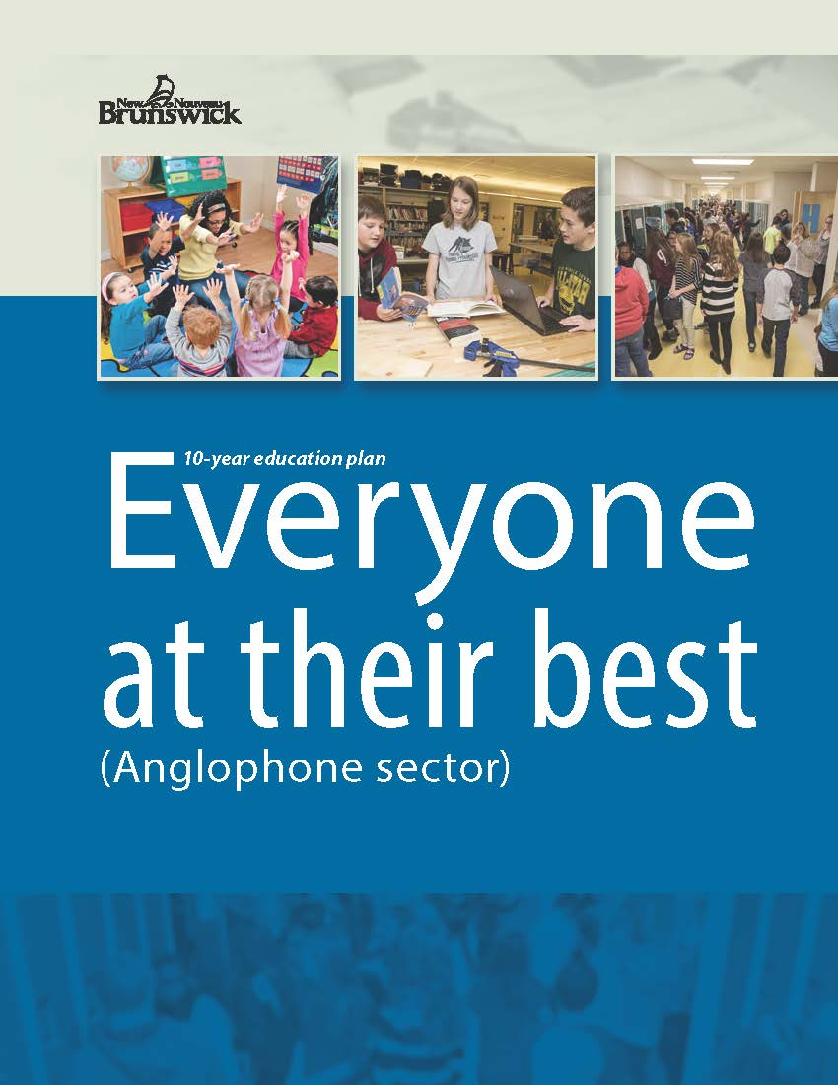

.

# Kindergarten

**Literacy**

* We will continue to work on adding details to their writing. Next we will work on adding punctuation,

as well as reading their words as they write.

* We will continue to work on using the reading strategy “stretchy snake” to sound words out

**Numeracy**

* Kindergarten students will be learning about 3-D objects. They will be sorting 3-D objects, describing them, and building with them.

**You and Your World**

#### We will continue to learn about Healthy Lifestyles.

#### Grade One

**Literacy**

❖  We are continuing to focus on revising our writing piece, especially in the areas of conventions (ie; punctuation and upper case letters).

❖  In Daily 5, we will continue to work on individual reading goals such as comprehension, fluency and looking for "chunks" or known parts of a word to figure out unknown words.

**Numeracy:**

* Completing unit on 2-D shapes and 3-D objects
* Mental Math

**You and Your World:**

* Healthy Living, Environment